THE HISTORY AND STRUCTURE OF DNA NOTES
Biology B
DNA (Deoxyribonucleic Acid)
History
Frederick Griffith:
- 1928 – Frederick Griffith was trying to figure out how bacteria made people sick.
- _____________ – infection that inflames air sacs in one or both lungs, which may fill with fluid.
- Found two strains of bacteria of the same species
  - Smooth (_______)
  - Rough (_______)
- Only the _________ strain caused pneumonia
- Experimented with mice.
- When he injected the mice with the ________ bacteria, it caused pneumonia
- When he injected the mice with the _______ bacteria, the mice remained _______
- He “heat treated” the smooth bacteria
  - This killed the smooth bacteria cells
  - He injected the “heat treated” smooth bacteria into the mice
  - They ________________
- Next experiment:
  - He ________ the “heat treated” smooth bacteria with the harmless rough bacteria
  - Injected this mix into the mice
- SHOCKING RESULTS!!!!!!
  - This mix actually made the mice ______
  - How could this happen if the S-strain cells were dead?

Transformation
- Griffith reasoned that when he mixed the “heat treated” smooth bacteria and the rough bacteria cells, a __________________ had been transferred from the smooth bacteria cells to the rough bacteria cells
  - This is called __________________.
  - This chemical factor must contain information that could change the harmless bacteria into disease-causing bacteria
Oswald Avery
- 1944 - Avery’s team conducted experiments to narrow down the chemical compound that caused the __________________ in the bacteria cells.
  - They treated the bacteria with __________ that killed proteins, lipids, carbohydrates and other molecules
  - Transformation still happened
  - When they _______________ (deoxyribonucleic acid), transformation did not occur
    - DNA WAS THE TRANSFORMING FACTOR!!!
- Virus – tiny, nonliving particles that can infect living cells
- Bacteriophage – a kind of virus that infects bacteria.
Hershey and Chase
- Alfred ________ and Martha ________ conducted experiments on bacteriophage viruses
  - Their experiments ________ that DNA was the cell’s genetic material in all living cells
- How could DNA be capable of doing the following with genetic information in the cell?
  - ____________
  - ____________
  - ____________
THE STRUCTURE OF DNA
- DNA – a nucleic acid made up of nucleotides joined into long strands or chains by covalent bonds

- Nucleotides are made up of three basic components:
  - 5-carbon ________ – deoxyribose
  - A _________ group
  - A nitrogenous _________
    - Adenine (A)
    - Guanine (G)
    - Cytosine (C )
    - Thymine (T)
Erwin Chargaff
- Chargaff conducted experiments and found that:
- __________ (A) and Thymine (T) were found in equal amounts
- Guanine (G) and __________ (C ) were found in equal amounts

___________ must pair with Thymine.
___________ must pair with Cytosine.
The bases form weak hydrogen bonds.

Rosalind Franklin
- 1952: Used _______ diffraction to show the pattern of DNA
  - _______ – twisted like the coils of a spring
- 1953: James Watson and Francis Crick used Franklin’s X-ray pattern to build a _______ of the specific structure of DNA
Structure of DNA
- Double Helix – two strands coiled to resemble a twisted __________
- “Legs of the ladder” – ___________ and Sugar
- “Rungs of the ladder” – Nitrogenous _______ pairs
  - Nitrogenous bases held together with weak hydrogen bonds
- The “legs” and “rungs” together made nucleotides.
Antiparallel Molecule
- Antiparallel molecule – the two strands run alongside each other, but point in __________ directions.
- In a double-stranded DNA molecule, the 5' end (____________-bearing end) of one strand aligns with the 3' end( ___________-bearing end)
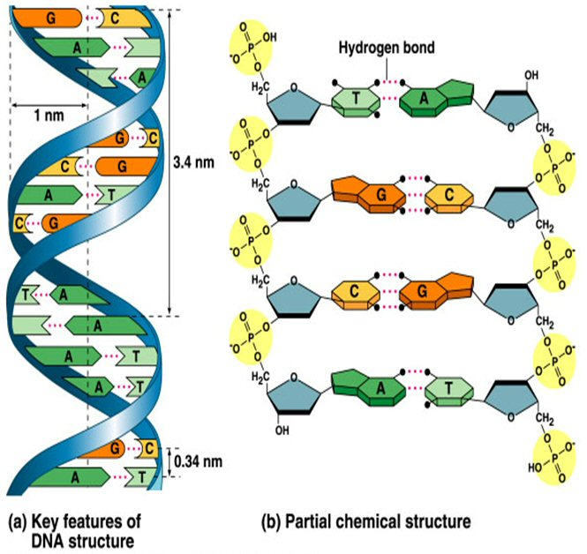
Base Pairings
- Adenine (A) pairs with Thymine (T)
- ________
- Guanine (G) pairs with Cytosine (C )
- ________
- Pyrimidines:
  - Thymine (T)
  - Cytosine (C )
- Purines
  - Adenine (A)
  - Guanine (G)
- Pyrimidines pair with Purines!

